CSE488: Big Data Analytics

[SPRING 2023]

Assignment

Title of the Assignment: Online Assignment Lab 03

Submitted by:

Student ID:2019-2-60-072

Student Name: Mujahidul Islam

Main Class code:

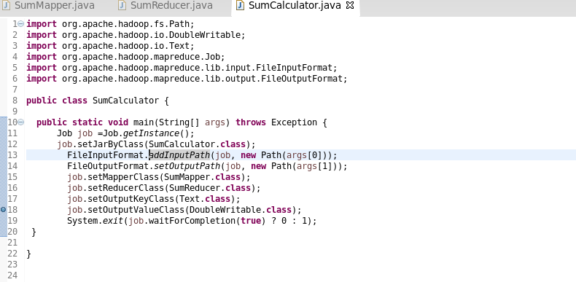

Mapper Class:

Reducer Class:

Input Files:

Execution Command Prompt:

Output:

